**5.6 sparse patterns**

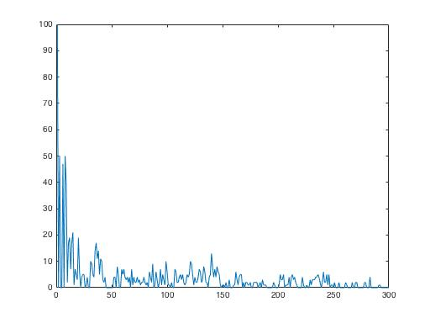

Set rho = 0.1 and theta = 0.1, the capacity is increased to around 50.

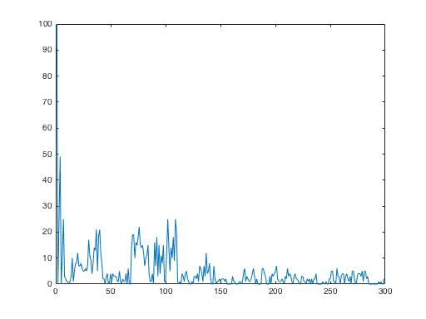

Set rho = 0.05 and theta = 0.1, the capacity is increased to around 110

